Database Project

Project Details:
IDE : Eclipse
Backend: Java
FrontEnd: JavaFX
Database: Mysql Workbench
Project Folder Structure:
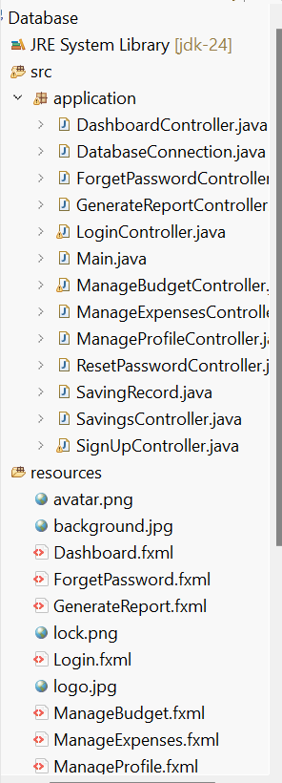
Note:
Paste the .java files and fxml files in the folder with the same sequence and folder name ,create the database (sql files are also present in .zip file) and run the program.

